**Quizzie App: A Web Application for Quizzing and Tracking Scores**

Overview

The Quizzie App is a web application that allows users to take quizzes on Math, English, and Science, in various difficulties; track their scores, and reset their scores. The app is built using HTML, CSS, JavaScript, Flask, a lightweight Python web framework, and MySQL, a relational database management system.

Features

- User registration and login: Users can create an account and log in to access the quiz. If username or password has already been taken a message will appear telling you so, as well as if username and/or password is invalid.

- Session management: The application manages user sessions to keep track of logged-in users.

- Database integration: The application uses a MySQL database to store user information and quiz scores for each subject and difficulty.

- Subject-specific routes: There are separate routes for each subject and difficulty level to provide a seamless experience.

- Score tracking: The application allows users to submit and reset their scores for each quiz.

- User-friendly interface: The application utilizes Bootstrap CSS framework and jQuery to create an intuitive and visually appealing user interface.

Installation

1. Clone the Quizzie App repository from GitHub.

2. Install the required Python packages using `pip install -r requirements.txt`.

3. Create a MySQL database named `users` and import the `users.sql` file into it.

4. Configure the database connection in the `app.config` dictionary in the `app.py` file.

5. Run the app using `python app.py`.

Usage

1. Open your web browser and navigate to `http://localhost:5000`.

2. Click on the "Register" link to create a new user account.

3. Enter your username and password and click on the "Register" button.

4. Once registered, you will be automatically logged in.

5. Click on the "Scores" link to view your scores.

6. Click on the "Reset Scores" button to reset your scores.

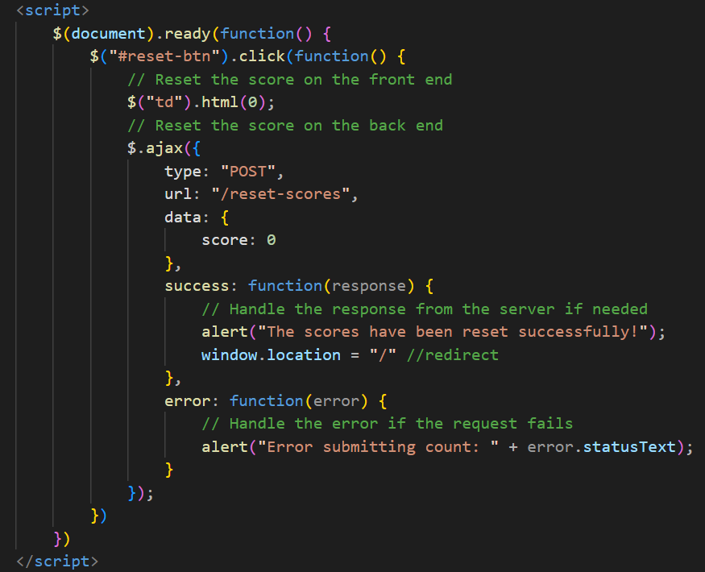

7. Click on the "Maths", "English", or "Science" links and their difficulty to take the quiz.

8. Watch out for the timer and complete the quiz before it runs out.

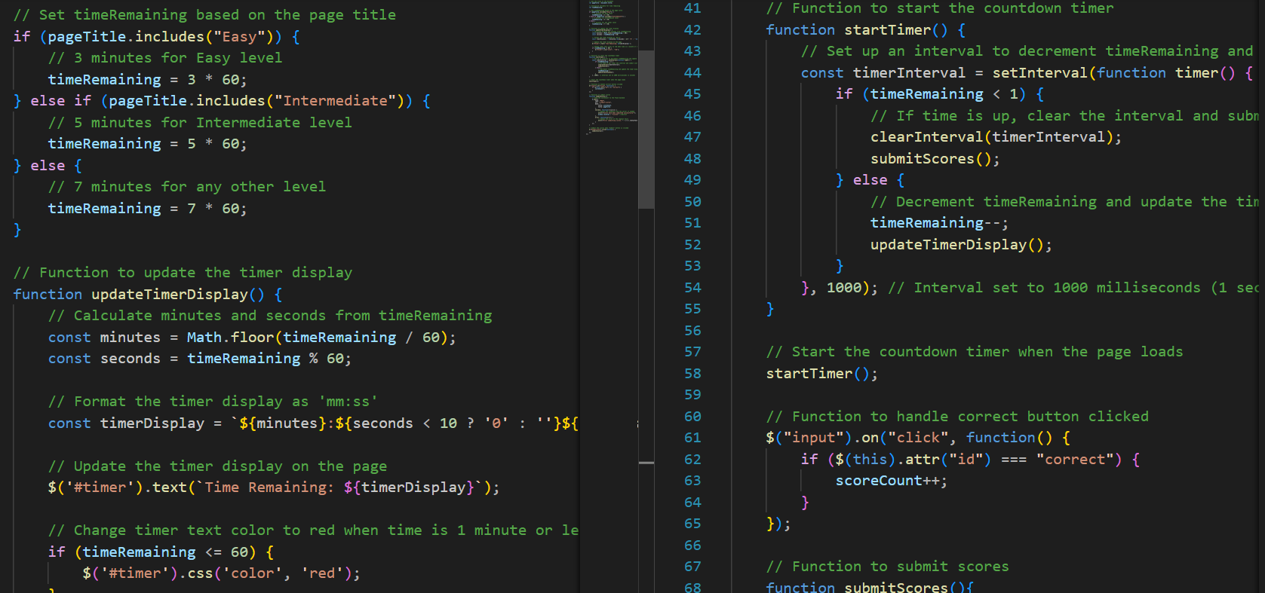

9. Answer the questions and click on the "Submit" button.

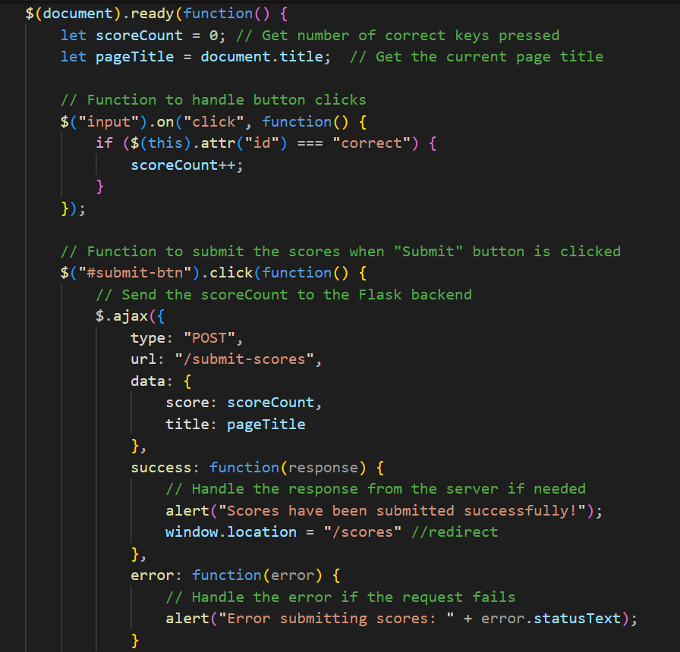

10. Your score will be displayed on the next page.

I learned the fundamentals of full-stack development, which involves working on both the front end (HTML, CSS, JavaScript) and the back end (Python). I understand more about the flow of data between the front end, back end, and the database, this allowed me to create comprehensive web applications that handle user interactions and data processing. Building a trivia application involves user interaction, and you likely gained experience in handling user inputs and providing feedback. You learned how to interact with a database to store and retrieve information.

Integration of Front End, Back End, and Database:

You gained experience in integrating different components of a web application. Connecting the front end to the back end and ensuring smooth communication with the database is a crucial aspect of building a functional and dynamic web app.

You understand the flow of data between the front end, back end, and the database. Managing the way data is sent, received, and stored is a critical skill in web development. Building a trivia application involves user interaction, and you likely gained experience in handling user inputs and providing feedback. You learned how to interact with a database to store and retrieve information.

Hey there! I'm a computer science student in Istanbul, Turkey, navigating my coding journey amidst a language barrier that limits my access to local hackathons and coding clubs. To make up for it, I've been diving into online courses like CS50 and META. Despite the challenges, my passion for software development keeps me going. The MLH Fellowship seems like the perfect opportunity to break through these barriers, learn from awesome mentors, and collaborate on exciting projects. I'm eager to be part of a diverse community that values inclusivity and learning, believing it would be a game-changer for my growth as a developer.

I strongly believe that participating in the MLH Fellowship would be transformative and significantly contribute to my growth as a full-stack software developer, both personally and professionally.

Mlh

Briefly describe what this code sample does:

The Quizzie App is a web application that allows users to take quizzes on Math, English, and Science, in various difficulties; track their scores, and reset their scores. The app is built using HTML, CSS, JavaScript, Flask, a lightweight Python web framework, and MySQL.

Briefly describe what you learned when you created this code sample:

I learned the fundamentals of full-stack development, which involves working on both the front end (HTML, CSS, JavaScript) and the back end (Python). I understand more about the flow of data between the front end, back end, and the database, this allowed me to create comprehensive web applications that handle user interactions and data processing.

I have a good academic background in computer science, which equips me with a solid understanding of fundamental concepts in programming and software development. This knowledge base will enable me to engage in meaningful discussions and support fellow members in their learning journeys.

Why do you want to become an MLH Fellow?

I'm keen on becoming an MLH Fellow because it presents a golden opportunity to immerse myself in hands-on learning, real-world projects, and collaborative problem-solving, all while benefitting from the guidance of expert mentors. The MLH fellowship invites people from diverse groups regardless of their background and experiences, this aligns perfectly with the kind of community I am eager to be part of. I'm interested in gaining experiences that go beyond the classroom, and the MLH Fellowship provides exactly that. I am confident this fellowship will be a game-changer for my growth as a developer.

I want to be a MLH fellow because I would get the chance to learn, build and gain real world experience, collaborate and solve problems under expert mentors. The MLH fellowship invites people from diverse groups regardless of their background and experiences, that’s the kind of community I want to be a part of. I'm eager to be part of a diverse community that values inclusivity and learning. The MLH Fellowship provides the perfect opportunity to learn from awesome mentors, and collaborate on exciting projects. I am confident this would be a game-changer for my growth as a developer.

"I aspire to become an MLH Fellow because it offers a unique opportunity to learn, build, and gain real-world experience while collaborating on problem-solving projects under the guidance of expert mentors. The inclusive nature of the MLH Fellowship, which embraces individuals from diverse backgrounds, aligns perfectly with the kind of community I am eager to be part of. I am enthusiastic about joining a community that values inclusivity and continuous learning. The MLH Fellowship not only provides the perfect platform to learn from exceptional mentors but also presents exciting collaborative projects. I am confident that being a part of this fellowship would be a pivotal moment in my journey as a developer, facilitating substantial growth and learning."

The MLH Fellowship's commitment to diversity, welcoming individuals from various backgrounds, resonates with my vision of an inclusive and dynamic community. As a third-year student, I'm hungry for experiences that go beyond the classroom, and the MLH Fellowship stands out as the ideal space to interact with inspiring mentors, contribute to exciting projects, and propel my growth as a developer. I am confident that this fellowship will be a pivotal moment in shaping my skills and perspective in my journey towards becoming a seasoned developer."

The MLH Fellowship is a diverse community that welcomes Fellows from a wide range of experiences and backgrounds. What perspective or experience will you bring to the fellowship to strengthen our community?

I am excited to bring my experience to the table. Having tutored junior students and collaborated on various group projects, I deeply understand the value of mentorship and teamwork within a learning community. Through coursework, and personal projects, I have gained hands-on experience in both front-end and back-end development. This practical knowledge will be valuable in contributing to the collaborative projects within the MLH Fellowship.

Constant exposure to an international environment has sharpened my adaptability, communication skills, and effectiveness in working within diverse settings. I am excited about the prospect of adding my unique perspective and skills to further strengthen the MLH Fellowship community.

Anything else about yourself;

I am a computer science student based in Istanbul, Turkey. Despite facing challenges with the language barrier, I am determined to advance my skills and knowledge in programming. Unfortunately, the local accessibility to hackathons, coding clubs, or groups is limited for me. To make up for it, I've been diving into online courses like CS50, Codecademy and META. I strongly believe that participating in the MLH Fellowship would be a transformative experience for me and I am confident that it would significantly contribute to my personal and professional growth in becoming a full stack software developer.